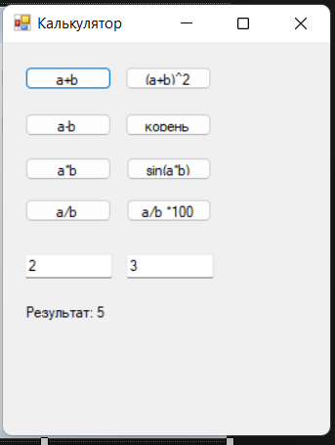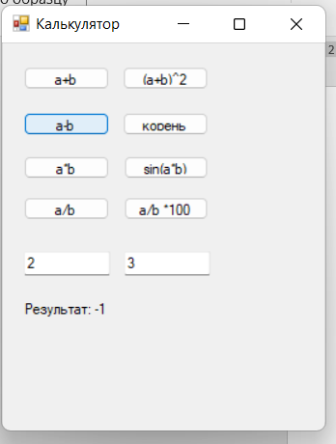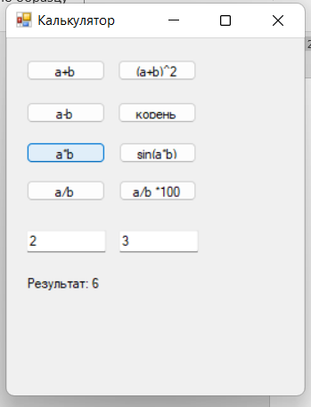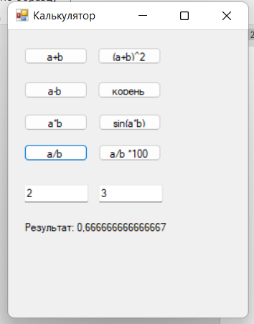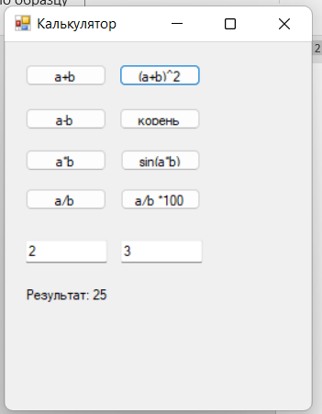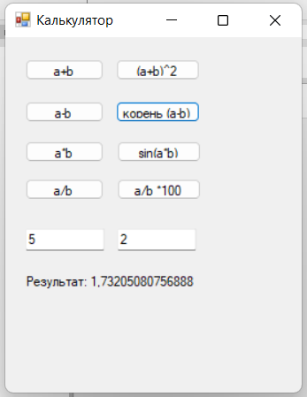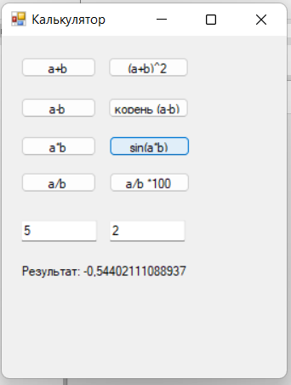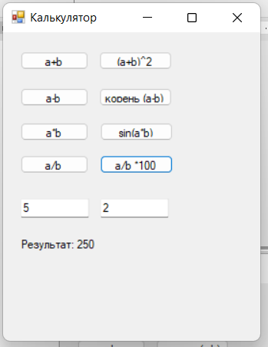

using System;

using System.Collections.Generic;

using System.ComponentModel;

using System.Data;

using System.Drawing;

using System.Linq;

using System.Text;

using System.Threading.Tasks;

using System.Windows.Forms;

namespace Практическая_2

{

public partial class Form1 : Form

{

public Form1()

{

InitializeComponent();

}

private void Form1_Load(object sender, EventArgs e)

{

}

private void button1_Click(object sender, EventArgs e)

{

PerformOperation((a, b) => a + b);

}

private void button2_Click(object sender, EventArgs e)

{

PerformOperation((a, b) => a - b);

}

private void button3_Click(object sender, EventArgs e)

{

PerformOperation((a, b) => a * b);

}

private void button4_Click(object sender, EventArgs e)

{

PerformOperation((a, b) =>

{

if (b == 0)

{

MessageBox.Show("На ноль делить нельзя.");

return 0;

}

return a / b;

});

}

private void PerformOperation(Func<double, double, double> operation)

{

if (double.TryParse(textBox1.Text, out double num1) &&

double.TryParse(textBox2.Text, out double num2))

{

double result = operation(num1, num2);

label1.Text = $"Результат: {result}";

}

else

{

MessageBox.Show("Пожалуйста, введите корректные числа.");

}

}

private void button5_Click(object sender, EventArgs e)

{

PerformOperation((a, b) => (a + b)*(a + b));

}

private void button6_Click(object sender, EventArgs e)

{

PerformOperation((a, b) => Math.Sqrt(a - b));

}

private void button7_Click(object sender, EventArgs e)

{

PerformOperation((a, b) => Math.Sin(a * b));

}

private void button8_Click(object sender, EventArgs e)

{

PerformOperation((a, b) => (a / b)*100);

}

}

}

Задание 2

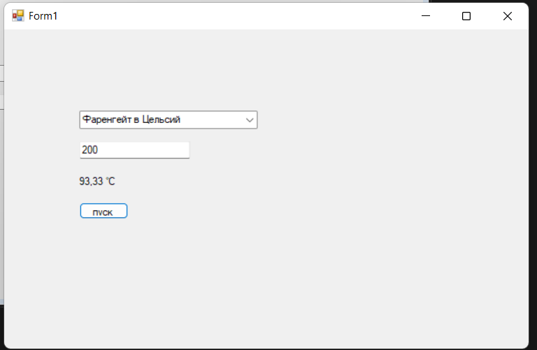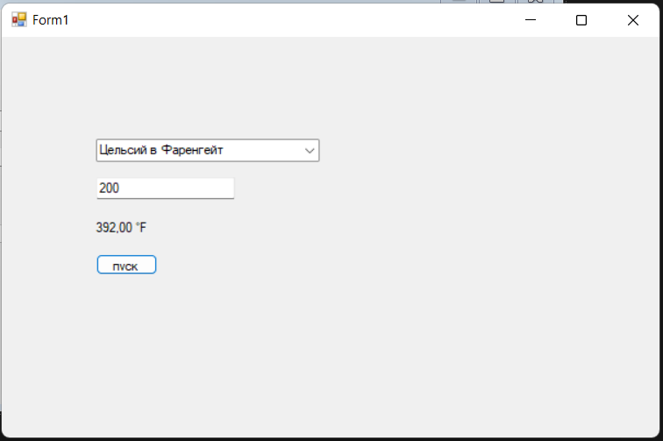

Задание 3.

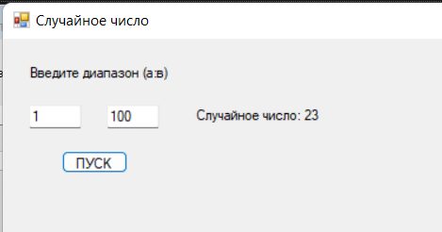

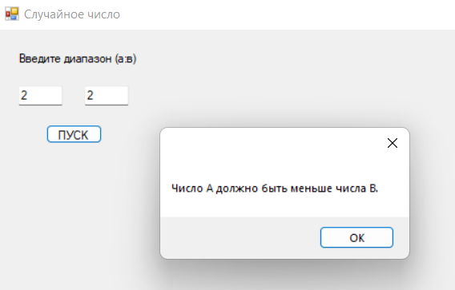

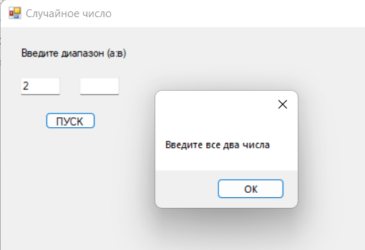

using System;

using System.Collections.Generic;

using System.ComponentModel;

using System.Data;

using System.Drawing;

using System.Linq;

using System.Text;

using System.Threading.Tasks;

using System.Windows.Forms;

namespace Практическая_2_3

{

public partial class Form1 : Form

{

public Form1()

{

InitializeComponent();

}

private void button1_Click(object sender, EventArgs e)

{

if (int.TryParse(textBox1.Text, out int a) && int.TryParse(textBox2.Text, out int b))

{

if (a < b)

{

Random random = new Random();

int randomNumber = random.Next(a, b + 1);

label1.Text = $"Случайное число: {randomNumber}";

}

else

{

MessageBox.Show("Число A должно быть меньше числа В.");

}

}

else

{

MessageBox.Show("Введите все два числа");

}

}

}

}